Report on Additive Manufacturing
Student’s Name
Institutional Affiliation

Report on Additive Manufacturing
Introduction
Additive manufacturing entails series of production processes used to manufacture low-volume standardized engineering designs through repeatability. The process ensures efficacy in dimensional capacity that are economically viable. The production volumes are optimized while maintaining the geometrical complexity. The standardization of the designs enables them to meet the changing market needs. The manufacturing technique is applicable especially in the locomotives, defense, and medical industry. The methodology results in the production of quality designs through extensive assessment of their internal infrastructure. Consequently, the structure and the geometry undergo solidification and vaporization for complete transformation of the designs (Ituarte et al. 2015). The geometrical properties of the materials are stabilized to superior architectural designs. The parameters involved in the manufacturing process are dependent on the planning of the planning of the whole system. The technology has helped in providing alternatives to machines processes that manufacture complex designs.
The process ensures simultaneous manufacturing of designs with different dimensional and mechanical capabilities. The lab report will evaluate the correct combination required to satisfy the multiple dimensional requirements. The report, therefore, will provide extensive conceptual frameworks on how additive manufacturing eliminate tradeoffs to become more superior to the traditional subtractive manufacturing. The mechanism is advantageous since it ensures that materials manufactured are less costly, is lighter, and produces fewer waste products (Brown et al. 2013). As compared to subtractive manufacturing, articles produced exhibit more physical strength and versatility. The design process encompasses modeling and testing that eliminate errors that are developed during the manufacturing process.
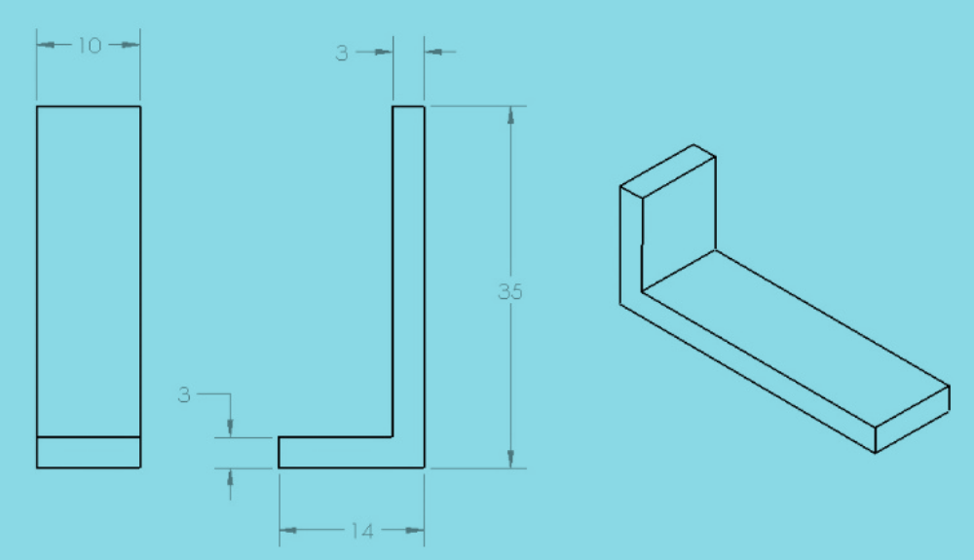
Fig.1 Geometry of Parts from Additive Manufacturing
Aim
The experiment aims to assess the operational requirements and the fundamental processes involved in additive manufacturing. Also, the experiment seeks to evaluate the process characterization that helps in improving the material, geometrical, and dimensional capabilities.

Method

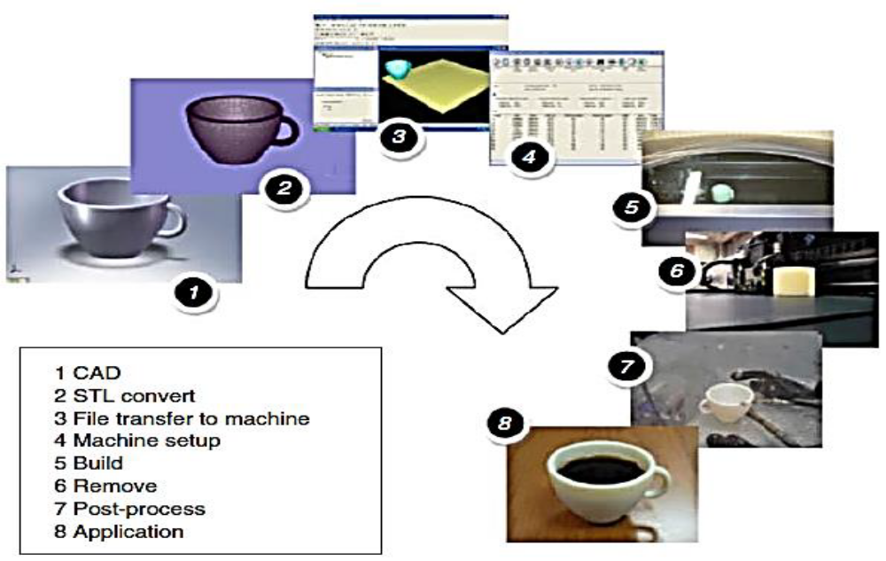
Fig. 2 Additive Manufacturing using CAD Data
The lab research used case geometry samples that are used in mass production of materials after being subjected to injection molding. The samples had low dimensional and geometrical tolerances to ensure ease of assembly of the final product. The experiment used samples of standardized dimensions, and that met the geometrical specifications. Afterward, the appropriate geometry was selected from the CAD data. The experiment also determined the factors that affected the performance of the parameters which included signal, control, and noise factors. The machine was oriented to produce material of different geometries (horizontal, vertical, and diagonal dimensions). The XY horizontal plane was inclined at 45º to align the manufacturing machines. The parts were located and printed to the right, left, top, and bottom of the building platform. Also, the quality of the digital data was assessed to identify and remove errors. The parameters were subjected to standardized tests to improve the performance of the process machines. The test was used to build straight and circular dimensional characteristics. The results were used to compare the capabilities of the device with the design parameters. The processes were combined using under optimum conditions resulting in additive manufacturing.
Results
The experiment produced many combinations that did not satisfy the geometrical requirements of the materials. However, specific combinations produced designs that were technologically viable for additive manufacturing. The filtering results showed that at the first two stages of the process removed the material jetting and powder bed fusion. From the performance assessment, polymerization provided optimal results since it produced materials with better surface qualities, that is, the elements had superior flatness and hole distance. Testing of the process enabled materials of better robustness quality to be formed, and parts with defects had potential remanufacturing capabilities. The mean value of the parameter performance lied within the required index. Also, other stages had mean values outside the mechanical requirements as a result of surface roughness. The standard deviations of the parameter performance showed variation from the centre of the variable distribution.
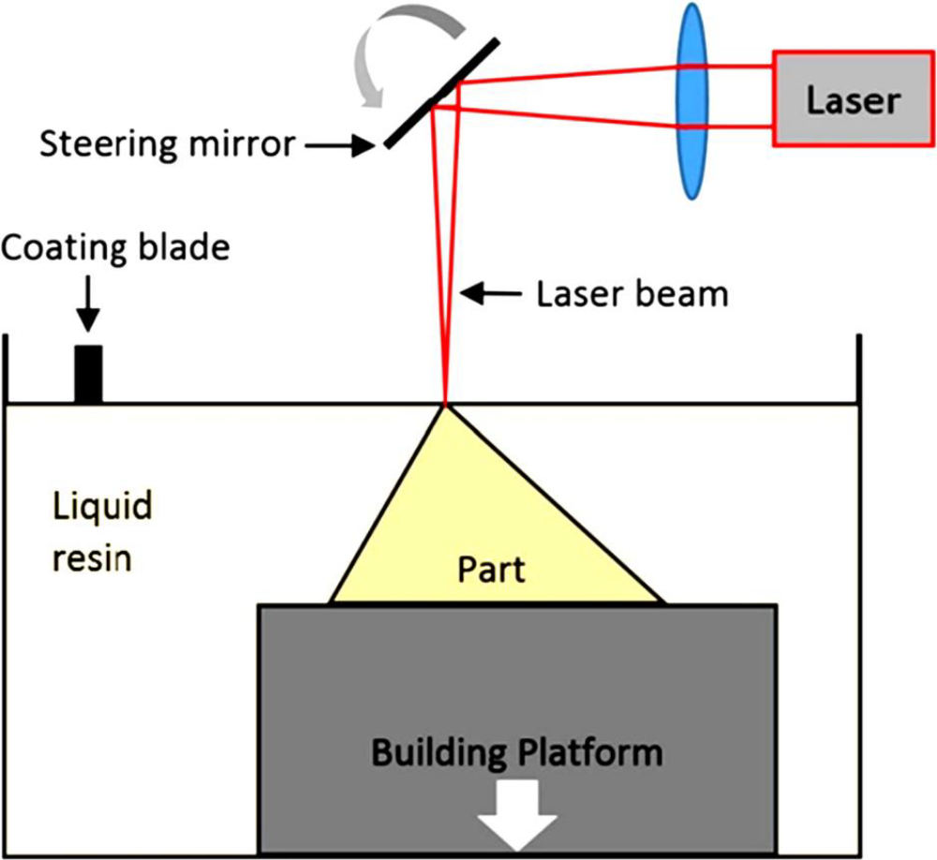
Fig. 3 Laser Polymerization from Additive Schematic Manufacturing

Discussion of Results
The prototypes from additive manufacturing resulted in a series of processes that reduced the cost of the materials. The process speeded the manufacturing process by the use of combinations that enabled the production of materials with the right geometrical and dimensional capabilities. The surface requirements were satisfied using filtering methods that ensured that the mean values fell within the stipulated performance requirements. The various stages within the manufacturing process simultaneously provided feasible market materials. The costs for flatness met the required quality since the components were produced diagonally, vertically, and horizontally aligned to the centre of the processing machine (Ituarte et al. 2015). The effectiveness of the digital processing technique ensured that production of linear and circular surfaces. The material characteristics were compared with the producers' specifications providing the molding requirements were satisfied.
Technicalities of manufacturing plastics components were eliminated by using a case sample that exhibited high quality. Weaker results from the comparison exercise were eliminated through injection of the molded parts while the relatively stronger elements were stabilized using laser machines. The acceptable range of performance was made possible by measuring the mechanical properties of the selected materials. The thermoplastic feedstock condensed vapors from the organic synthesis of the materials resulting in products of different chemical compositions. The defects within the materials, therefore, were determined by measuring the sizes of the tiny particles (McDonald & Wlodwick, 2013). The chemical composition of the materials was made compatible to the toxicity of the case samples to enable the production of final products within uniform internal and external infrastructure.
Conclusion
The experiment was able to highlight that additive manufacturing produces materials with superior mechanical, geometrical, and dimensional capabilities. The process also showed that low-volume materials could be produced massively at affordable price ranges. The efficacy of the manufacturing process also ensured that fewer waste materials were produced. In this regard, unlike subtractive manufacturing, additive manufacturing provided optimization of the production process. For optimal production results, different combinations of the substrate were determined to produce designs that met the geometrical and the dimensional requirements. A case sample was used to act as an index from which selected combinations would be compared. The case sample was of high quality to ensure that there were minimal defects within the final products. Besides, the chemical composition of the substrate was determined from the tiny components injected as a result of the molded materials. The reduction of deficiencies was made possible by subjecting the material prototype to testing methodologies. Quality assurance played an integral part in the manufacturing process since it ensured that the performance characteristics of the prototypes fell within the stipulated range. The performance levels that fell outside the required range were subjected to the re-crystallization process. In conclusion, additive manufacturing is suitable for mass production as compared to other manufacturing methods.

References
Brown, C., Lubell, J., & Lipman, R. (2013). Additive manufacturing technical workshop report.
National Institute of Standards and Technology. 1-60.
Ituarte, I. F. Coantanea, E., Salmi, M., Tuomi, J., & Partanen, J. (2015). Additive manufacturing
In production: A study case applying technical requirements. Journal of Physics Procedia. Science Direct. 78 (1). 357-366.
McDonald, N. P. & Wlodkowic, D. (2013). Additive manufacturing of lab-on-a-chip devices:
Promises and challenges. Research Gate. 1- 15.

